**2019 Challenge**

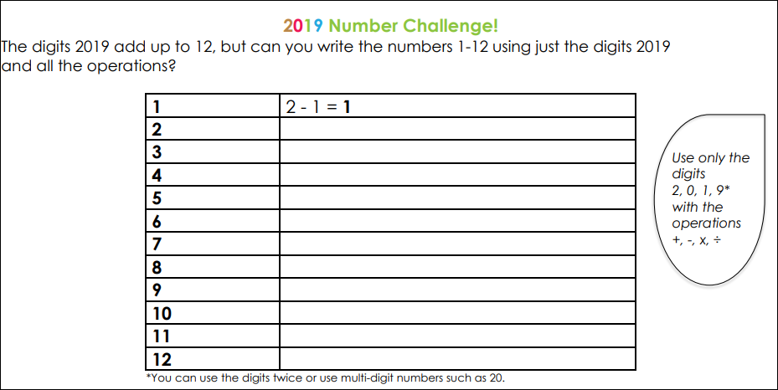

What about the numbers 13 -20?

Are you able to find solutions for them?