Solving Problems using tenths

\*

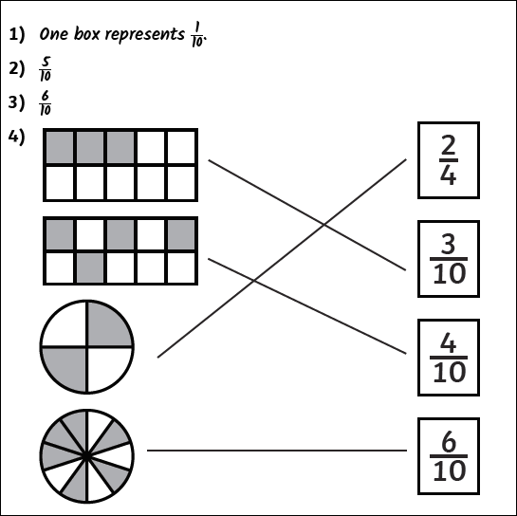

\*\*

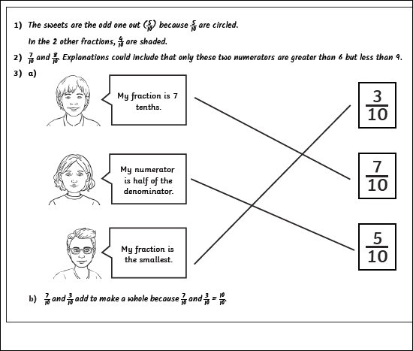

4. 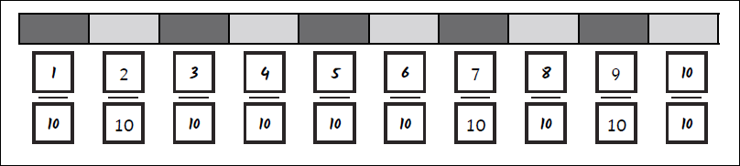

5. 

6. 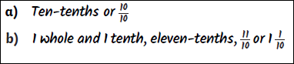

\*\*\*

1.

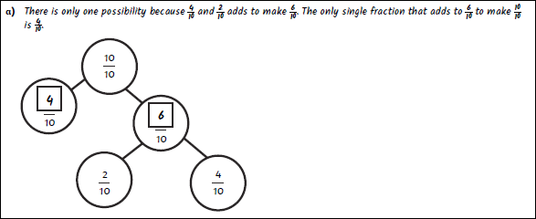

b. your solutions