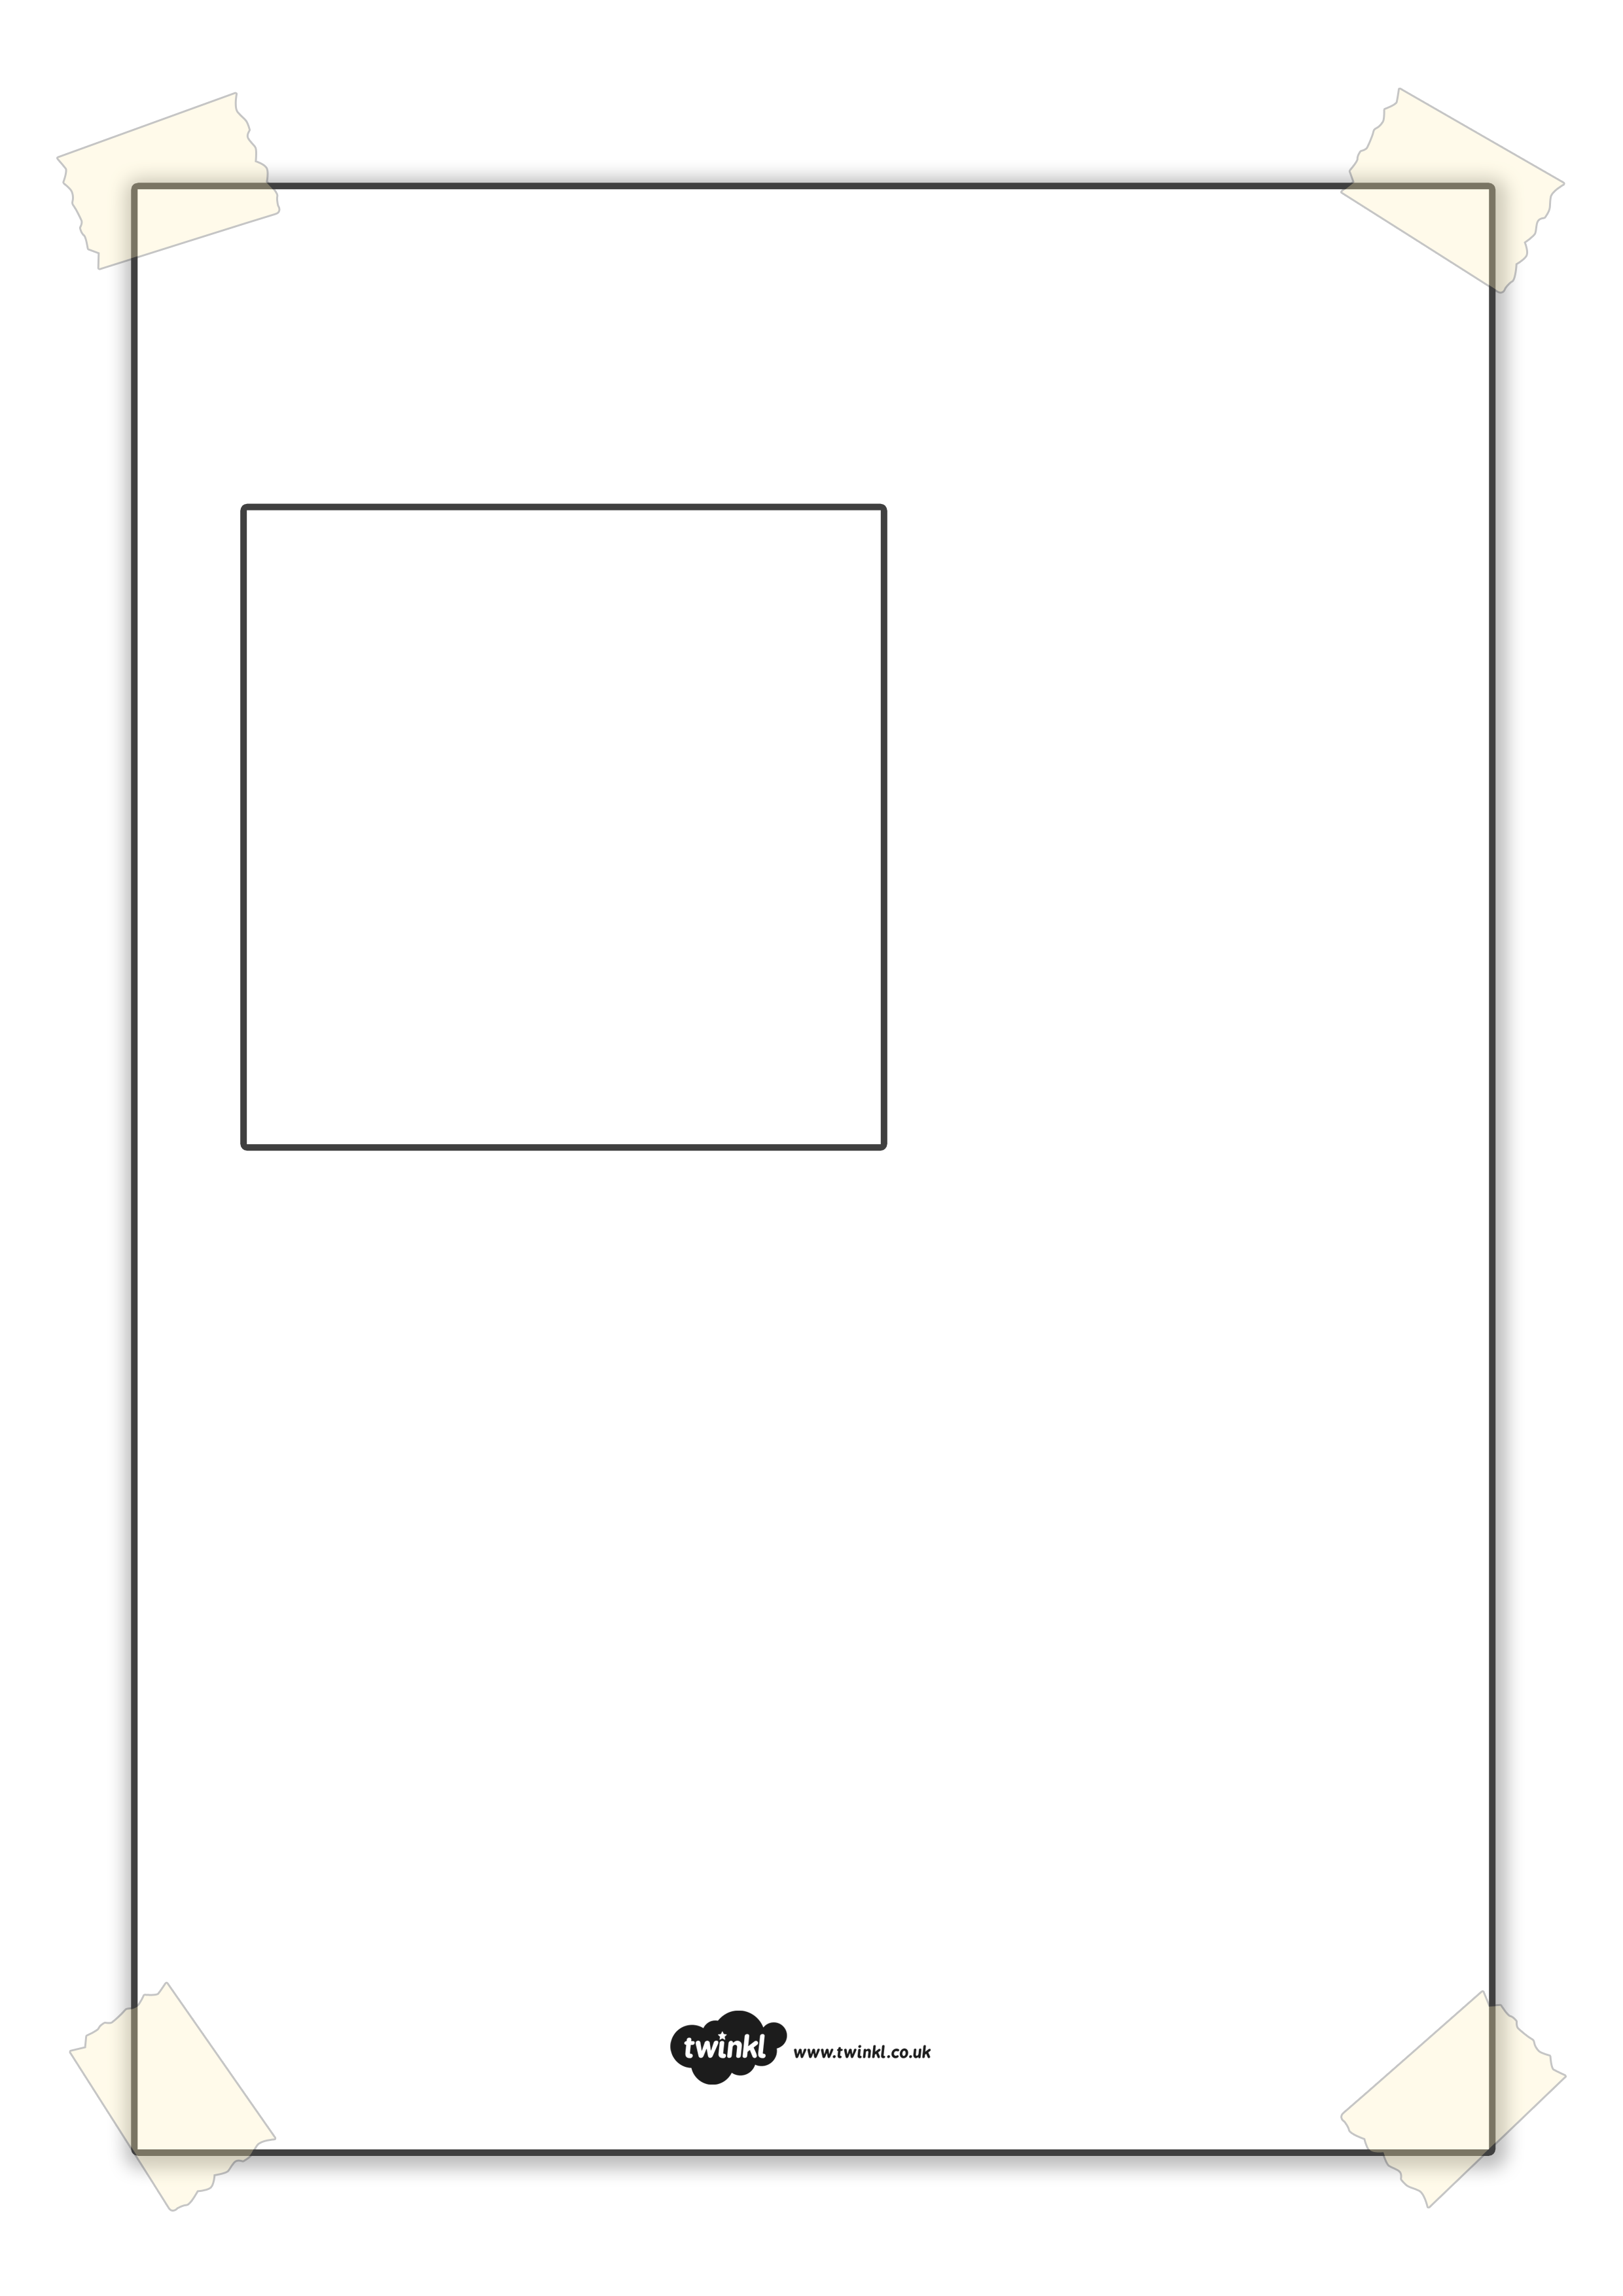
LOST!
Description:

We are learning to create a lost poster for
Stick Man.

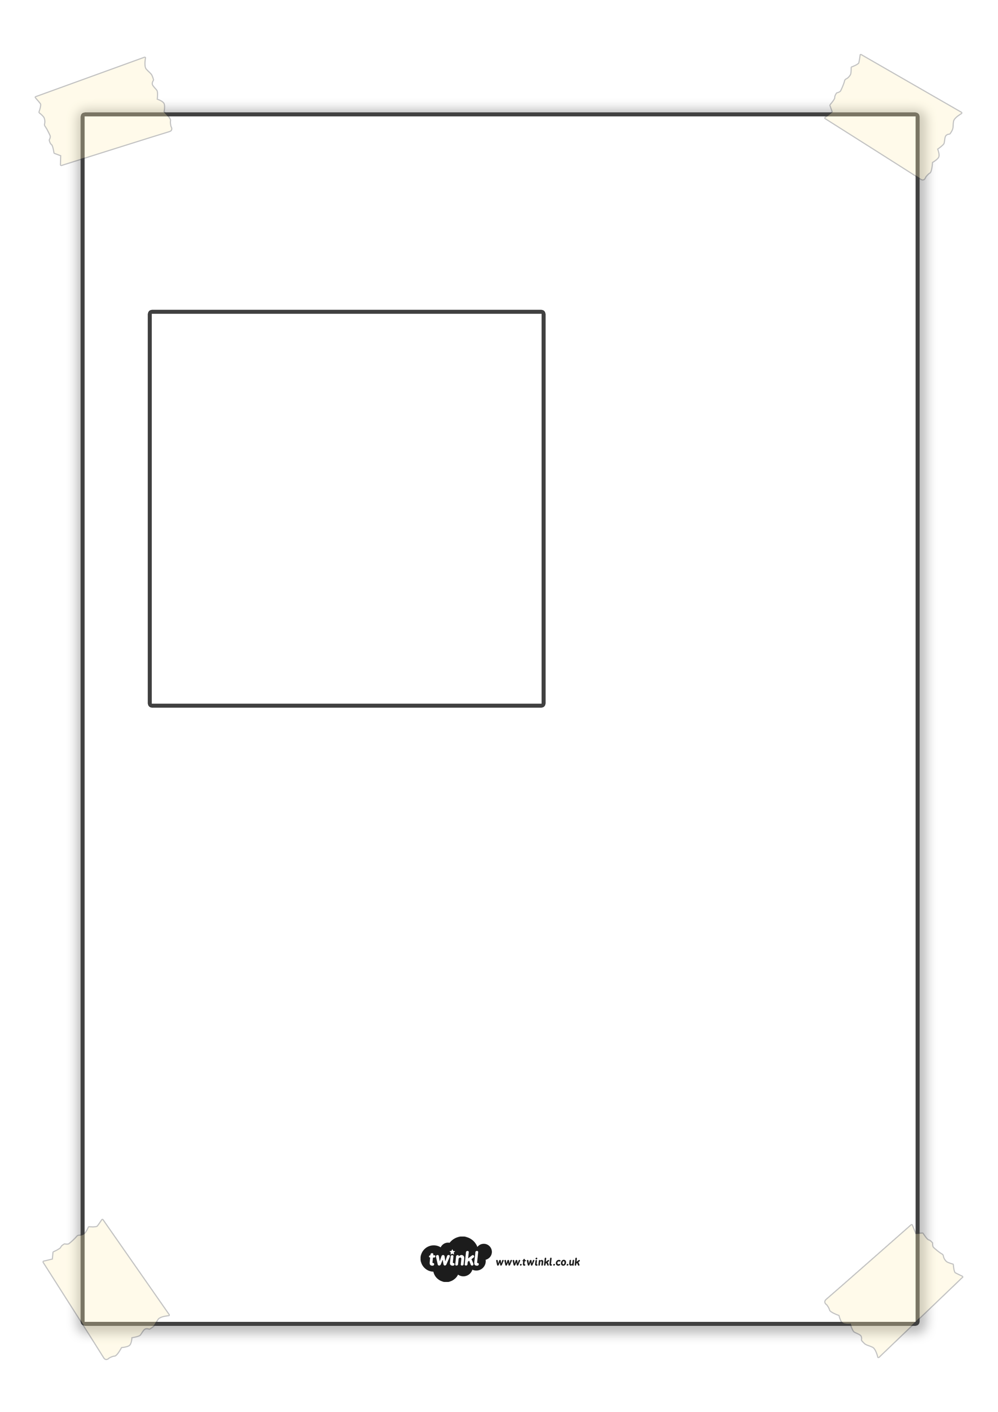
MISSING!
Pet’s Name:

Type of pet:

Last Seen:

If found, please contact:

Description:

