
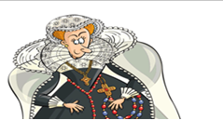
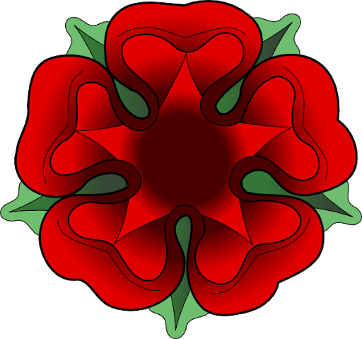

Topic Project homework: You must choose a minimum of 3 tasks to complete over the next half term. You must complete at least the compulsory tasks – highlighted in blue.
Tudor Collage:  Create a Tudor collage of images. Use different textures and materials if you can.  Dojo Points: 10 - 15 | Poem:  Write a poem or song which summarizes an event in the Tudor period. Make it catchy and remember to include key terms.  Dojo Points: 10 - 15 | Tudor Top Trumps:  Create a top trump card for Henry VIII. Include a picture and interesting facts.  Dojo Points: 10 - 15
Signature: | Signature: | Signature:
Tudor Timeline:  Create a timeline of Tudor events. This can be presented in a PowerPoint, Poster, etc.  Dojo Points: 10 - 15 | Historic London:  Visit the Globe Theatre or Tower of London and find out more about Tudor history. Create a photo diary of the day with thoughts and experiences.  Dojo Points: 10 - 15 | Henry’s Wives:  Create a graph that shows how long each of Henry VIII’s wives lived for. You could use a bar chart or a line graph. What information can you get from your graph?  Dojo Points: 10 - 15
Signature: | Signature: | Signature:
Tudor Writing:  Find a picture from the internet of each of King Henry VIII’s wives and write ‘DIVORCED, BEHEADED, DIED, DIVORCED, BEHEADED SURIVIVED’ next to them. Try to write in Tudor style writing!  Dojo Points: 10 - 15 | Fashion:  Create a magazine cover. What were the women of the time wearing? What colours and fabrics were fashionable?  Dojo Points: 10 - 15 | Tudor Rose:  Make a beautiful Tudor Rose from felt or another material. Decorate with gems and ribbons if you want to!  Dojo Points: 10 - 15
Signature: | Signature: | Signature:
Tudor Portrait:  Paint a portrait of a Tudor Monarch or of a wife of King Henry the VIII.  Dojo Points: 10 - 15 | Tudor Buildings:  Research Tudor style buildings and go on a ‘Tudor House Walk’ in your area (or beyond!). Print out a photo diary of your walk.  Dojo Points: 10 - 15 | Tudor Wordle:  Create a Tudor Wordle on the computer using key words from what you have learnt.  Dojo Points: 10 - 15
Signature: | Signature: | Signature:
Reflection: What tasks did you enjoy the most?

