**Examples of Introductions**

Are you having trouble with a dragon? Need help to catch that monstrous nightmare? If a dragon is on the loose in your kingdom, you can be left in a bit of a sticky wicket. Follow these set of instructions and you will never have to fear a dragon again.

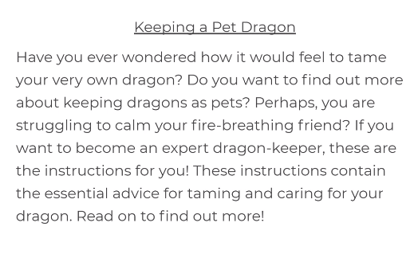

Are you kept awake at night by the sound of dragons crunching bones? If so, do not despair. Help is at hand. Dragons must be defeated. Read these instructions and soon you too will be rid of this terrible pest.