**Henry VIII Fact File**

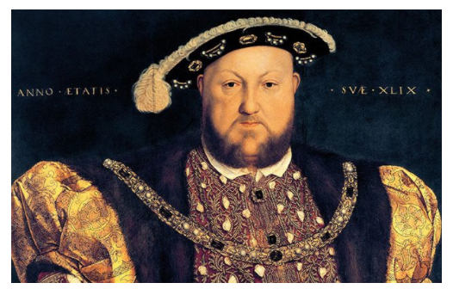

**Name:** Henry Tudor

**Who were they?** King of England

**Born:** 28 June 1491 in London, at Greenwich Palace.

**Died:**

**Reigned:**

**Spouses:**

**Children:**

**What he did:**

He created the Church of England and made himself head of the church.

**What he enjoyed doing:**

**Other Facts:**